1. Step: Profile Optimization SOP

Step 1: Profile Setup:
Go to the settings page.
https://www.pinterest.com/settings
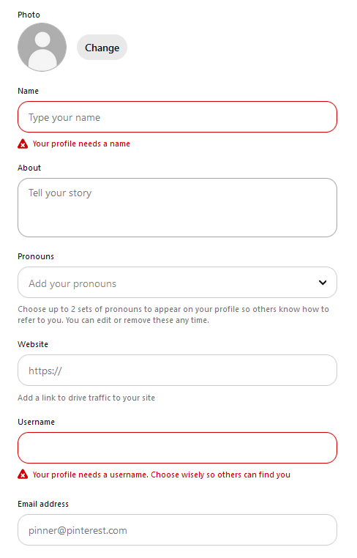
- Profile Photo:
  - If you have a personal blog/brand, use a personal photo.
  - If you have a niche site blog, use a simple minimalistic logo.
- Example of how I like to set up my logos:
(keep it lean & simple)

- Profile Name:
  - Use your personal name or your site's name.
  - Add 2-3 main topics you cover.
    - Pro Tip: If you have enough data, use the KWs of your best-performing boards.
  - Example: "YourBrandName | Home Decor and Interior Design"
- About:
  - Explain what topics your account covers.
  - Include 3-5 important KWs you cover.
  - Don't keyword-stuff.
- Website:
  - Add your main domain like yourbrandname.com
  - Claim your website under > settings > claimed accounts > websites
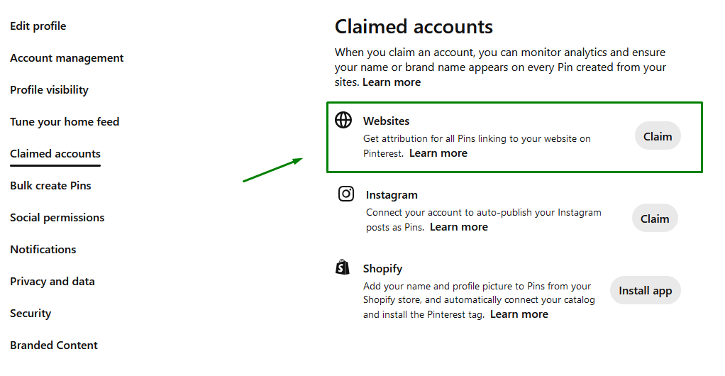
- Username:
  - Use your personal name or your site's name.
- Email Address:
  - Add your domain email here like: contact@yourbrandname.com

Step 2: Convert Your Account to a Business Account
https://www.pinterest.com/settings/account-settings/
Under Account Management, you’ll see a button "convert account".
This gives you access to analytics.
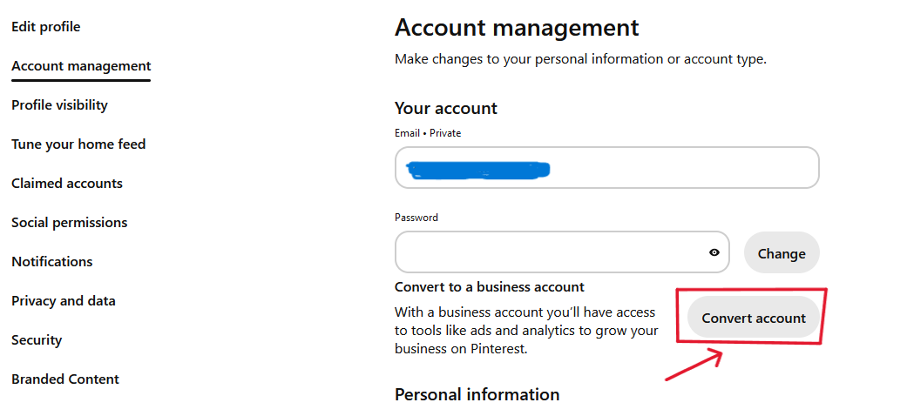

Other:
- Add your first boards
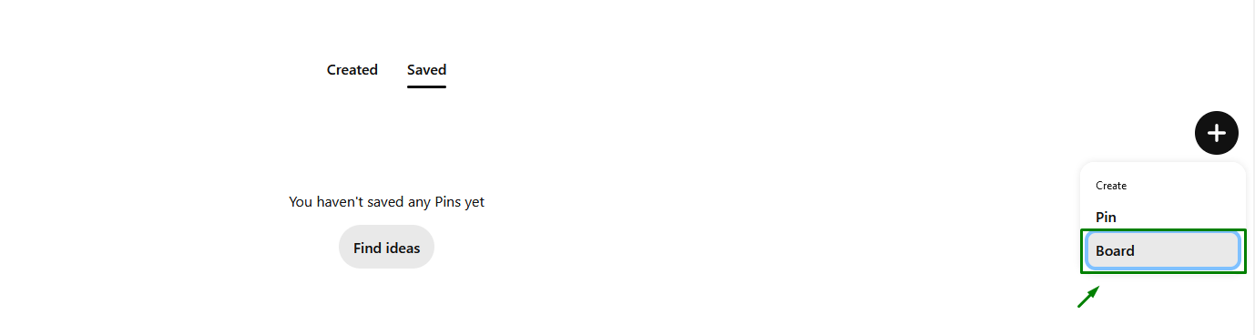
  - Add relevant board descriptions (with 4-6 relevant annotation keywords)
  - Save 3-5 relevant pins from others
You can do that easily inside your board under "find some ideas for this board"
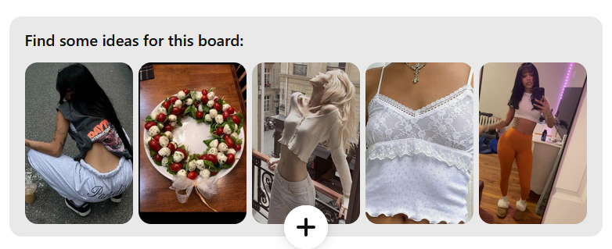
- Follow other relevant accounts & interact with them (like, comment, save)
- If you don't live in the US but would like to get most of your traffic from there, I recommend switching your account to United States.
  - Under account management > Personal information
